DEPARTMENT OF BOTANY

GUEST LECTURE
ACADEMIC YEAR- (2025-2026)

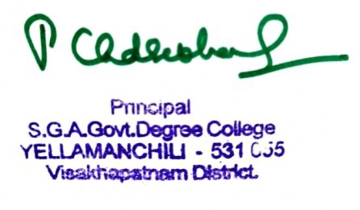
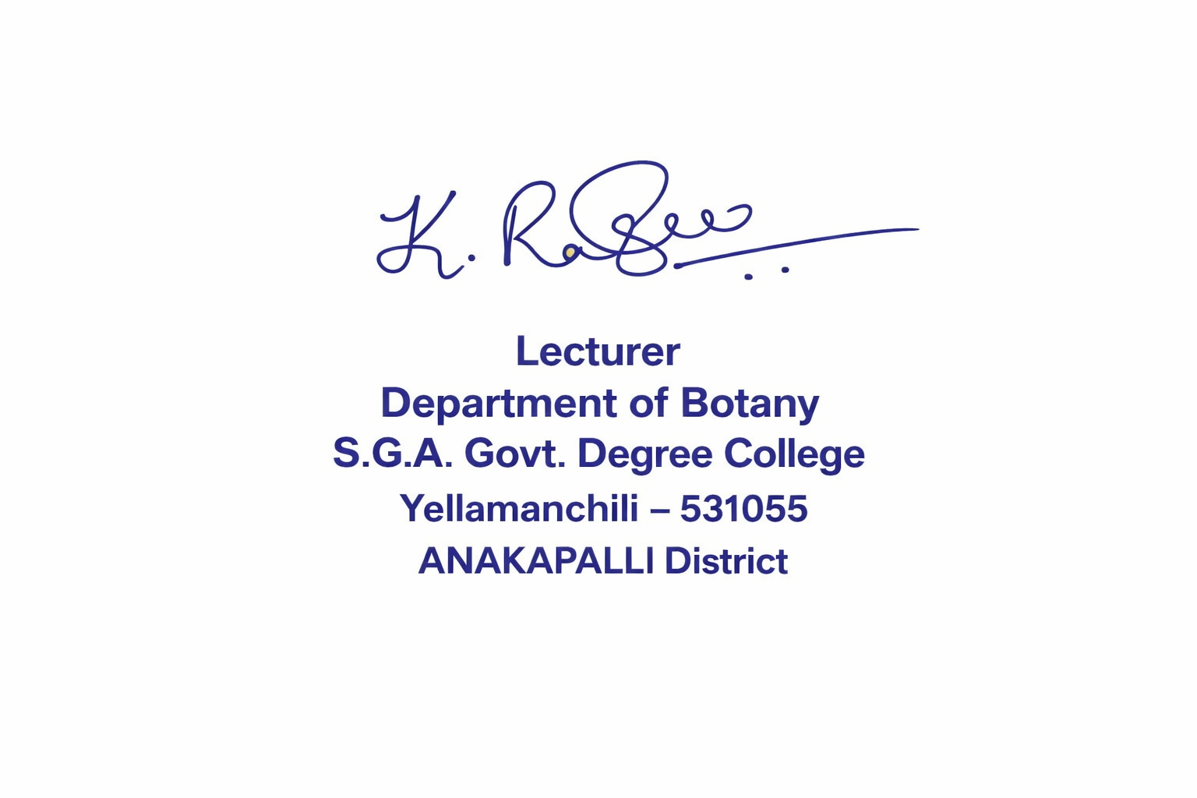

SIGNATURE OF LECTURER SIGNATURE OF PRINCIPAL

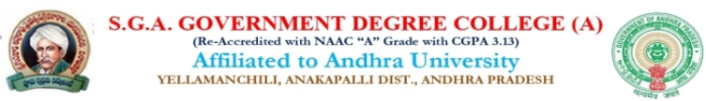
DEPARTMENT OF BOTANY
GUEST LECTURE BY SRI M. HARI BABU
LECTURER IN BOTANY (AMAL COLLEGE ANAKAPALLE)
TOPIC: THALLOPHYTES DATE: 10-11-2025
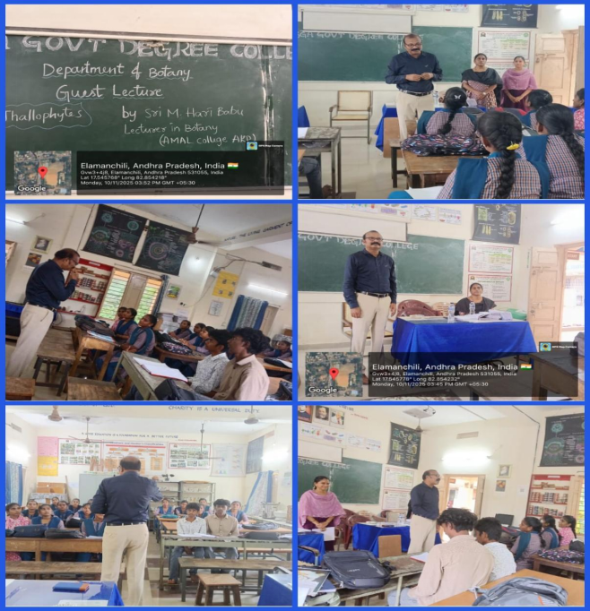

Report on Guest Lecture
Topic: Thallophytes
Guest Speaker: M. Haribabu
Institution: AMAL College
A guest lecture on “Thallophytes” was delivered by M. Haribabu from AMAL College. The lecture was organized to help students gain a better understanding of the characteristics and importance of thallophytes in the plant kingdom.
The speaker began the lecture by explaining the classification of plants, focusing mainly on thallophytes. He described thallophytes as simple plants that do not have true roots, stems, or leaves. Their body is called a thallus, which is why they are placed under the group thallophytes.
During the lecture, he discussed different examples such as algae, fungi, and lichens. He explained their structure, habitat, and reproduction. He also highlighted the economic and ecological importance of these organisms, including their role in food production, medicine, and environmental balance.
The speaker used clear explanations and examples, which made the topic easy for students to understand. The lecture was very informative and interesting, and it helped students improve their knowledge of plant biology.
The session concluded with an interactive discussion, where students asked questions and clarified their doubts. Overall, the guest lecture was very useful and inspiring for all the participants.

DEPARTMENT OF BOTANY
GUEST LECTURE (24-01-26)
BY V. TEJASWINI PGT BOTANY (KGBV)
V. MADUGULA
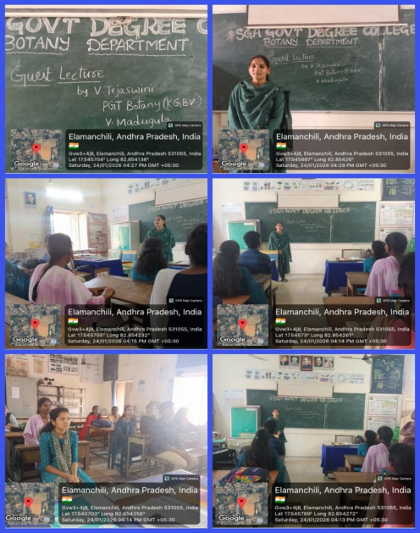
MICROBES BY BSc 2nd YEAR STUDENTS

Report on Guest Lecture
Topic: Microbes
Guest Speaker: V. Tejaswini
Institution: Kasturba Gandhi Balika Vidyalaya (KGBV)
A guest lecture on “Microbes” was delivered by V. Tejaswini from Kasturba Gandhi Balika Vidyalaya (KGBV). The purpose of the lecture was to provide students with knowledge about microorganisms and their importance in daily life.
The speaker began the lecture by explaining what microbes are. She described microbes as very small living organisms that cannot be seen with the naked eye and can only be observed under a microscope. She explained that microbes include bacteria, viruses, fungi, and protozoa.
During the lecture, she discussed the different types of microbes, their characteristics, and their habitats. She also explained how microbes can be both useful and harmful. Useful microbes help in food production, medicine, agriculture, and environmental processes, while harmful microbes can cause various diseases.
The speaker also emphasized the importance of maintaining hygiene and cleanliness to prevent microbial infections. She encouraged students to develop awareness about health and sanitation.
The lecture was very informative and interesting for the students. It helped them understand the importance of microbes and their role in nature and human life. The session ended with an interactive discussion, where students asked questions and clarified their doubts. Overall, the guest lecture was very useful and educational.


DEPARTMENT OF BOTANY
MOTIVATION LECTURE BY SRI P.S.JAGGA RAO SIR
DEPARTMENT OF PHYSICS
HOW TO BUILD YOUR CAREER FOR III AND V SEMESTER STUDENTS (1-AUG-2025)
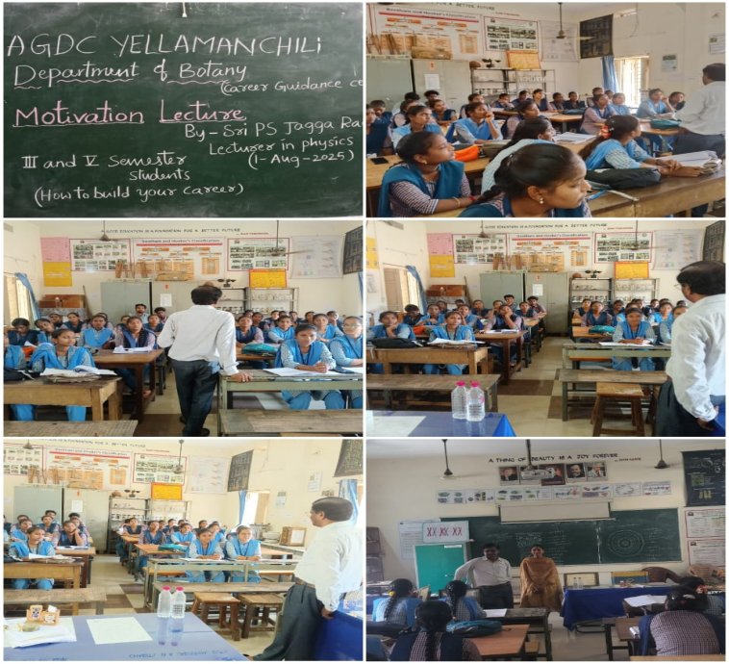

REPORT:

Report on Motivation Lecture
Topic: How to Build Your Career
Speaker: P. S. Jagga Rao
Department: Department of Physics
Group: I & II Bsc Botany
A motivational lecture on “How to Build Your Career” was delivered by P. S. Jagga Rao from the Department of Physics. The lecture was organized to guide students on planning their future and achieving success in their careers.
The speaker began the session by explaining the importance of setting clear goals in life. He emphasized that students should identify their interests and strengths before choosing a career path. He encouraged students to work hard, stay disciplined, and remain focused on their ambitions.
During the lecture, he also highlighted the value of education, continuous learning, and skill development. He advised students to improve their communication skills, gain practical knowledge, and keep updating themselves with new developments in their fields. According to him, self-confidence, determination, and positive thinking are essential qualities for building a successful career.
The speaker also shared examples and practical tips on time management, planning, and overcoming failures. He motivated students not to be afraid of challenges and to treat failures as learning opportunities.
The lecture was very informative and inspiring for all the students. It helped them understand how to plan their careers and motivated them to work hard to achieve their goals. The session ended with students feeling encouraged and confident about their future.

